Algorithms and Data Structures
Exercise 1: Inventory Management System
using System;
public interface ICustomerRepository
{
void GetCustomerById(int id);
}
public class CustomerRepository : ICustomerRepository
{
public void GetCustomerById(int id)
{
Console.WriteLine($"Customer with ID {id} retrieved from database.");
}
}
public class CustomerService
{
private readonly ICustomerRepository _repository;
public CustomerService(ICustomerRepository repository)
{
_repository = repository;
}
public void ShowCustomer(int id)
{
_repository.GetCustomerById(id);
}
}
class Program
{ static void Main(string[] args) {
ICustomerRepository repository = new CustomerRepository();
CustomerService service = new CustomerService(repository);
service.ShowCustomer(101);
}
}
Output-
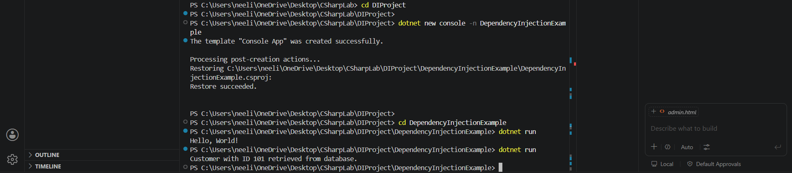
Exercise 2: E-commerce Platform Search Function
using System;
class Product
{
public int ProductId { get; set; }
public string ProductName { get; set; }
public string Category { get; set; }
public Product(int id, string name, string category)
{
ProductId = id;
ProductName = name;
Category = category;
}
}
class Program
{
static int LinearSearch(Product[] arr, string name) {
for (int i = 0; i < arr.Length; i++)
{
if (arr[i].ProductName == name)
return i;
}
return -1;
}
static int BinarySearch(Product[] arr, string name)
{
int left = 0, right = arr.Length - 1;
while (left <= right)
{
int mid = (left + right) / 2;
int cmp = string.Compare(arr[mid].ProductName, name);
if (cmp == 0)
return mid;
else if (cmp < 0)
left = mid + 1;
else
right = mid - 1;
}
return -1;
}
static void Main(string[] args)
{
Product[] products = {
new Product(101, "Laptop", "Electronics"),
new Product(102, "Mouse", "Electronics"),
new Product(103, "Shoes", "Fashion"),
new Product(104, "Watch", "Accessories"),
new Product(105, "Phone", "Electronics")
};
int result1 = LinearSearch(products, "Watch");
if (result1 != -1)
Console.WriteLine("Linear Search Found: " + products[result1].ProductName);
Array.Sort(products, (a, b) => a.ProductName.CompareTo(b.ProductName));
int result2 = BinarySearch(products, "Watch");
if (result2 != -1)
Console.WriteLine("Binary Search Found: " + products[result2].ProductName);
}
}
Output-
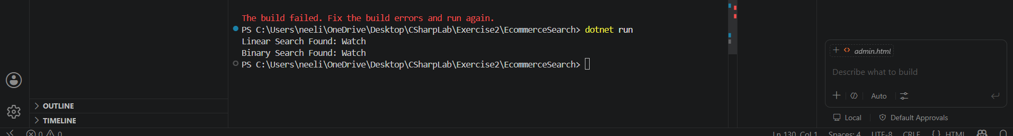
Exercise 3: Sorting Customer Orders
using System;
class Order
{
public int OrderId { get; set; }
public string CustomerName { get; set; }
public double TotalPrice { get; set; }
public Order(int id, string name, double price)
{
OrderId = id;
CustomerName = name;
TotalPrice = price;
}}
class Program
{ static void BubbleSort(Order[] arr)
{
int n = arr.Length;
for (int i = 0; i < n - 1; i++)
{
for (int j = 0; j < n - i - 1; j++)
{
if (arr[j].TotalPrice > arr[j + 1].TotalPrice)
{
Order temp = arr[j];
arr[j] = arr[j + 1];
arr[j + 1] = temp;
} }}}
static void QuickSort(Order[] arr, int low, int high)
{
if (low < high)
{
int pi = Partition(arr, low, high);
QuickSort(arr, low, pi - 1);
QuickSort(arr, pi + 1, high);
}
}
static int Partition(Order[] arr, int low, int high)
{
double pivot = arr[high].TotalPrice;
int i = low - 1;

for (int j = low; j < high; j++)
{
if (arr[j].TotalPrice < pivot)
{
i++;
Order temp = arr[i];
arr[i] = arr[j];
arr[j] = temp;
}
}
Order temp1 = arr[i + 1];
arr[i + 1] = arr[high];
arr[high] = temp1;
return i + 1;
}
static void PrintOrders(Order[] arr)
{
foreach (var o in arr)
{
Console.WriteLine($"{o.OrderId} | {o.CustomerName} | {o.TotalPrice}");
}
Console.WriteLine();
}
static void Main(string[] args)
{
Order[] orders = {
new Order(101, "Asha", 5000),
new Order(102, "Ravi", 1200),
new Order(103, "Kiran", 8000),
new Order(104, "John", 3000)
};
Order[] bubbleOrders = (Order[])orders.Clone();
Order[] quickOrders = (Order[])orders.Clone();
Console.WriteLine("Before Sorting:");
PrintOrders(orders);
BubbleSort(bubbleOrders);
Console.WriteLine("After Bubble Sort:");
PrintOrders(bubbleOrders);
QuickSort(quickOrders, 0, quickOrders.Length - 1);
Console.WriteLine("After Quick Sort:");
PrintOrders(quickOrders);
}
}
Output-
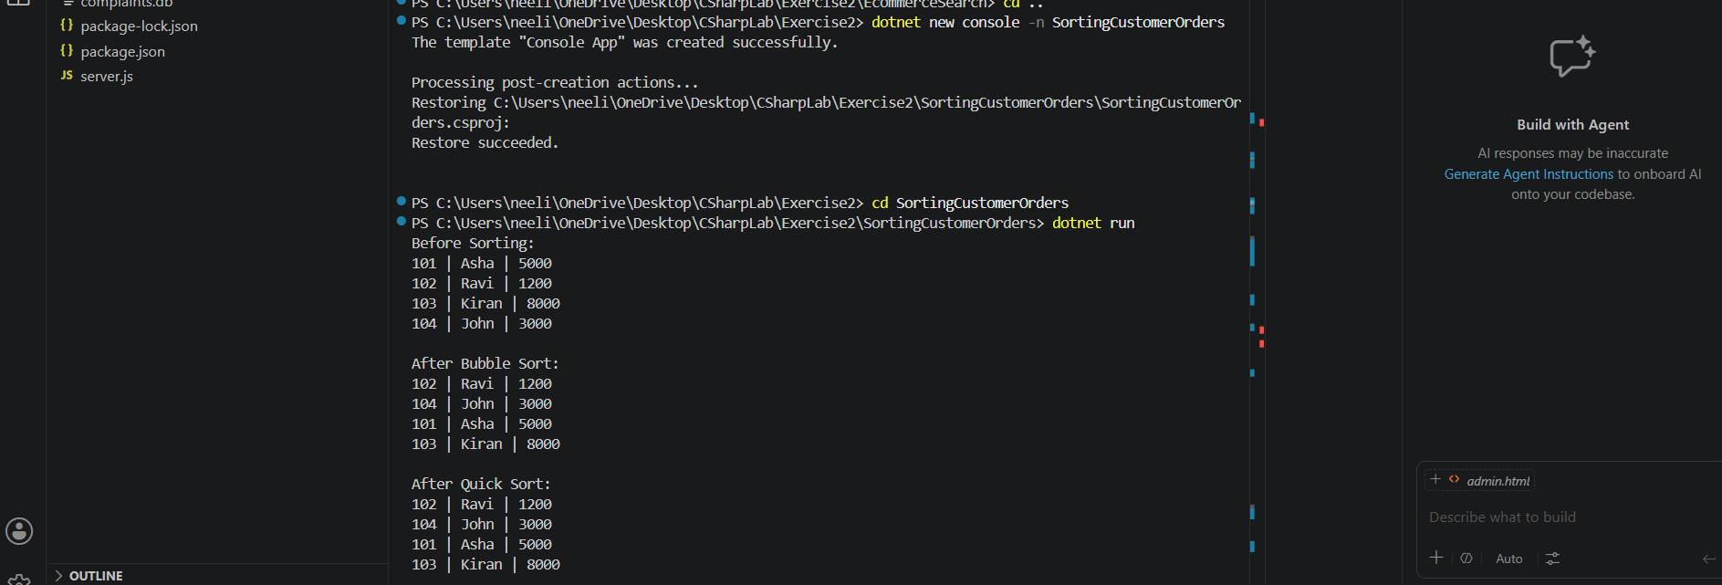
Exercise 4: Employee Management System
using System;
class Employee
{
public int EmployeeId { get; set; }
public string Name { get; set; }
public string Position { get; set; }
public double Salary { get; set; }
public Employee(int id, string name, string position, double salary)
{
EmployeeId = id;
Name = name;
Position = position;
Salary = salary;
}
}
class Program
{
static Employee[] employees = new Employee[10];
static int count = 0;
static void AddEmployee(Employee emp)
{
if (count < employees.Length)
{
employees[count] = emp;
count++;
Console.WriteLine("Employee added successfully");
}
else
{
Console.WriteLine("Array is full");
}
}
static void SearchEmployee(int id)
{
for (int i = 0; i < count; i++)
{
if (employees[i].EmployeeId == id)
{
Console.WriteLine($"Found: {employees[i].Name} | {employees[i].Position} | {employees[i].Salary}");
return;
}
}
Console.WriteLine("Employee not found");
}
static void DisplayEmployees()
{
Console.WriteLine("\nEmployee List:");
for (int i = 0; i < count; i++)
{
Console.WriteLine($"{employees[i].EmployeeId} | {employees[i].Name} | {employees[i].Position} | {employees[i].Salary}");
}
}
static void DeleteEmployee(int id)
{
int index = -1;

for (int i = 0; i < count; i++)
{
if (employees[i].EmployeeId == id)
{
index = i;
break;
}
}
if (index == -1)
{
Console.WriteLine("Employee not found");
return;
}
for (int i = index; i < count - 1; i++)
{
employees[i] = employees[i + 1];
}
count--;
Console.WriteLine("Employee deleted successfully");
}
static void Main(string[] args)
{
AddEmployee(new Employee(101, "Asha", "Manager", 50000));
AddEmployee(new Employee(102, "Ravi", "Developer", 40000));
AddEmployee(new Employee(103, "Kiran", "Tester", 30000));
DisplayEmployees();
SearchEmployee(102);
DeleteEmployee(102);
DisplayEmployees();
}
}
Output-
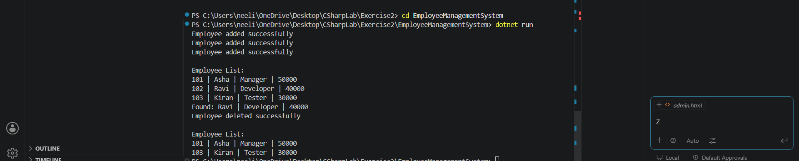
Exercise 5: Task Management System
using System;
class Task
{
public int TaskId;
public string TaskName;
public string Status;
public Task Next;
public Task(int id, string name, string status)
{
TaskId = id;
TaskName = name;
Status = status;
Next = null;
}
}
class TaskLinkedList
{
private Task head;
public void AddTask(Task newTask)
{ if (head == null)
{
head = newTask;
return;
}
Task temp = head;
while (temp.Next != null)
{
temp = temp.Next;
}
temp.Next = newTask;
}
public void SearchTask(int id)
{
Task temp = head;
while (temp != null)
{
if (temp.TaskId == id)
{
Console.WriteLine($"Found: {temp.TaskName} | {temp.Status}");
return;
}
temp = temp.Next;
}
Console.WriteLine("Task not found");
}
public void DisplayTasks()
{
Task temp = head;

Console.WriteLine("\nTask List:");
while (temp != null)
{
Console.WriteLine($"{temp.TaskId} | {temp.TaskName} | {temp.Status}");
temp = temp.Next;
}
}
public void DeleteTask(int id)
{
if (head == null)
{
Console.WriteLine("List is empty");
return;
}
if (head.TaskId == id)
{
head = head.Next;
Console.WriteLine("Task deleted");
return;
}
Task temp = head;
while (temp.Next != null && temp.Next.TaskId != id)
{
temp = temp.Next;
}
if (temp.Next == null)
{ Console.WriteLine("Task not found");
return;
}
temp.Next = temp.Next.Next;
Console.WriteLine("Task deleted");
}
}
class Program
{
static void Main(string[] args)
{
TaskLinkedList list = new TaskLinkedList();
list.AddTask(new Task(1, "Design UI", "Pending"));
list.AddTask(new Task(2, "Develop Backend", "In Progress"));
list.AddTask(new Task(3, "Testing", "Pending"));
list.DisplayTasks();
list.SearchTask(2);
list.DeleteTask(2);
list.DisplayTasks();
}
}
Output-
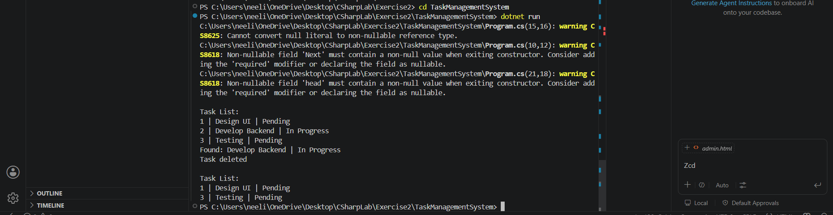
Exercise 6: Library Management System
using System;
class Book
{
public int BookId { get; set; }
public string Title { get; set; }
public string Author { get; set; }
public Book(int id, string title, string author)
{
BookId = id;
Title = title;
Author = author;
}
}
class Program
{
static int LinearSearch(Book[] books, string title)
{
for (int i = 0; i < books.Length; i++)
{
if (books[i].Title.Equals(title, StringComparison.OrdinalIgnoreCase))
return i;
}
return -1;
}
static int BinarySearch(Book[] books, string title)
{
int left = 0, right = books.Length - 1;
while (left <= right)
{
int mid = (left + right) / 2;
int compare = string.Compare(
books[mid].Title,
title,
StringComparison.OrdinalIgnoreCase
);
if (compare == 0)
return mid;
else if (compare < 0)
left = mid + 1;
else
right = mid - 1;
}
return -1;
}
static void Display(Book[] books)
{
foreach (var b in books)
{
Console.WriteLine($"{b.BookId} | {b.Title} | {b.Author}");
}
Console.WriteLine();
}
static void Main(string[] args)
{
Book[] books = {
new Book(101, "Java Basics", "James"),
new Book(102, "C# Fundamentals", "Mark"),
new Book(103, "Data Structures", "John"),
new Book(104, "Algorithms", "CLRS"),
new Book(105, "Python Guide", "Guido")
};
Console.WriteLine("Book List:");
Display(books);
int result1 = LinearSearch(books, "Algorithms");
if (result1 != -1)
Console.WriteLine("Linear Search Found: " + books[result1].Title);
else
Console.WriteLine("Not Found");
Array.Sort(books, (a, b) => a.Title.CompareTo(b.Title));
int result2 = BinarySearch(books, "Algorithms");
if (result2 != -1)
Console.WriteLine("Binary Search Found: " + books[result2].Title);
else
Console.WriteLine("Not Found");
}
}
Output-
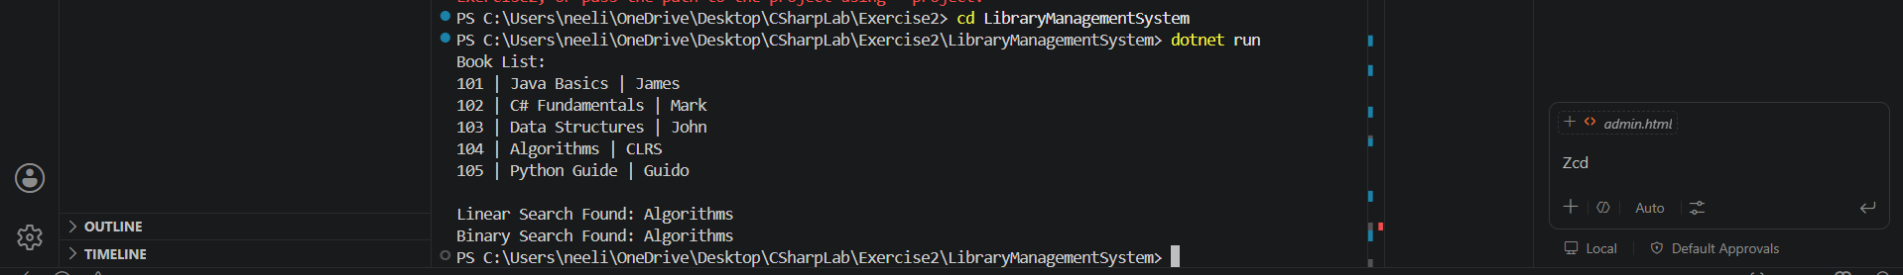
Exercise 7: Financial Forecasting
using System;
class Program
{
static double PredictValue(double value, double growthRate, int years)
{
if (years == 0)
return value;
return PredictValue(value, growthRate, years - 1) * (1 + growthRate);
}
static double PredictIterative(double value, double growthRate, int years)
{
for (int i = 0; i < years; i++)
{
value = value * (1 + growthRate);
}
return value;
}
static void Main(string[] args)
{
double initialValue = 1000;
double growthRate = 0.10;
int years = 5;
double recursiveResult = PredictValue(initialValue, growthRate, years);
double iterativeResult = PredictIterative(initialValue, growthRate, years);
Console.WriteLine("Initial Value: " + initialValue);
Console.WriteLine("Growth Rate: " + growthRate);
Console.WriteLine("Years: " + years);
Console.WriteLine("\nRecursive Result: " + recursiveResult);
Console.WriteLine("Iterative Result: " + iterativeResult);
}
}
Output-
